Introduction → Conceptual framing → Model → Results → Interpretation

*In gifbreeder, fix the broken phylogeny bug when you upload a genome and evolve from there

Things To Add
- Find the ancestor right before “animacy” and the one right after. What happened?? Do this with several different genomes. (!!!!)

Things To Keep
- Better understood as a compact spacetime field than as a physics simulation [x]
- It does not update a local state variable… it samples a closed-form network over spacetime coordinates
- Limbomorphs [x]
- Framing it as a time-based extension of Picbreeder where, accidentally, lifelike entities emerge under human selection
- Narrow the claim to apparent animacy in output space, future papers can make more ambitious claims
- I think it’s interesting to mention that if the image was static, it wouldn’t be possible to see any animacy (and show the figure to illustrate the point of how time unleashes the possibility for lifelike beings)
- Talk about how gifbreeder expressions have unbounded increases in complexity (point to Schrum paper for proof) and continue to make novel things and can easily move out of distribution
- Show the gif of the butterflies and make a point that any one frame is not particularly interesting, these patterns show up in many other expressions, time is what brings the GIFs to life. It’s also how these organisms move and flow within the frame that is interesting.
- Talk about how if the background is too noisy and cluttered, the “organism” isn’t salient, that humans may select for this solid background and self-contained organism motif because it’s what best activates our perception of animacy neuron. As if we were reverse engineering the brain, or how pawan sinha puts it (when talking about art), “Artists, they have essentially distilled their sensory experience into the keys that enable them to perceive what to understand.” Using art to understand the brain
- In the future work, discuss how deeper research could study if even more complex or apparently lifelike creatures are created, and if the evolution of these creatures reflect the evolution of biological life or stages of cognitive perceived animacy.
- Using a certain “species” or “family” as a case study
- The adversarial thing

Things To Toss:
- Tone is not calm and confident
- Do not overclaim

Introduction
Introduce IEC for Alife, NEAT, CPPNs, and ultimately picbreeder. Maybe also GIFs.

CPPNs and NEAT

Picbreeder
This was previously explored in AnimationBreeder

Methods
GIFBreeder is a web-based interactive evolutionary platform inspired by Picbreeder that uses NEAT-based search over CPPN representations to evolve animated GIFs through user-guided selection. The current implementation uses a population size of 20, up to 8 hidden nodes for each the initial random CPPN structure, and standard Picbreeder-style structural mutation and evolution over nodes, connections, weights, and activation functions. The chosen CPPN inputs are x, y, radial distance from center [(d = srt(X^2 + y^2))], time t, and a bias constant b. X and Y inputs are normalized between -0.5 and 0.5 while t is normalized between 0 and 1. The three outputs are interpreted and displayed as HSV channels but can be converted to RGB.

Formally, a genome parameterizes a CPPN

Fθ(x, y, d, t, b) → (h, s, v),

where θ denotes the network topology, activation functions, and connection weights, x and y are pixel coordinates, t is the current time step, and b is the bias node (always 1).

A phenotype is obtained by querying Fθ over a pixel grid and t = 45 timesteps, corresponding to 3 seconds at 15 frames per second. In the web-app implementation they are presented to the user as 64x64 spatial resolution renderings but in figures reported here, clips were rendered at 512 × 512 spatial resolution for analysis.

Because the phenotype is generated by normalized coordinate queries rather than a recurrent update rule, GIFBreeder is resolution invariant. GIFBreeeder defines a spacetime field rather than a simulated world. This distinction is central to the interpretation of the results below.

CPPNs
The set of functions used by CPPNs in GIFBreeder are sigmoid, tanh, Gaussian, sine, cosine, absolute value, ReLU, and identity. Some of these were adapted from the original picbreeder and others were added for experimental purposes. The kinds of activation functions chosen can bias the output and thus the activation functions were chosen to reflect nature. Sine and cosine were chosen as oscillation functions because wave-like, repeating spatial forms are common in nature [1, 2, 3, 4]. The Gaussian was chosen for its localized structure properties, allowing for blur, diffusion, and noise distribution [7, 8]. Sigmoid and tanh were chosen for their ability to represent smooth saturation and soft interfaces [10]. ReLU was chosen for its thresholding capacity [5, 6]. The absolute value and identity functions can be thought of as compact geometric priors that help reproduce the symmetries and local linearities common in nature [9]. All other functions and combinations of functions in the CPPN can also become stepping stones or building blocks for more complex composite functions and ultimately expressed features.

NEAT
The NEAT algorithm is used, just like in the original picbreeder, because of its ability to elaborate and complexify open-endedly. The exact implementation and hyperparameters, including mutation rates, weight perturbation rates, and initialization methods, can be found in the source code.

Results

Limbomorphs
Lifelike beings can sometimes emerge from within GIFBreeder phenotypes. These phenomenological beings, which we’ll call limbomorphs because they live in a liminal three-second world, can begin to emerge primitive animacy in as few as 7 generations and possibly fewer (figure 4).
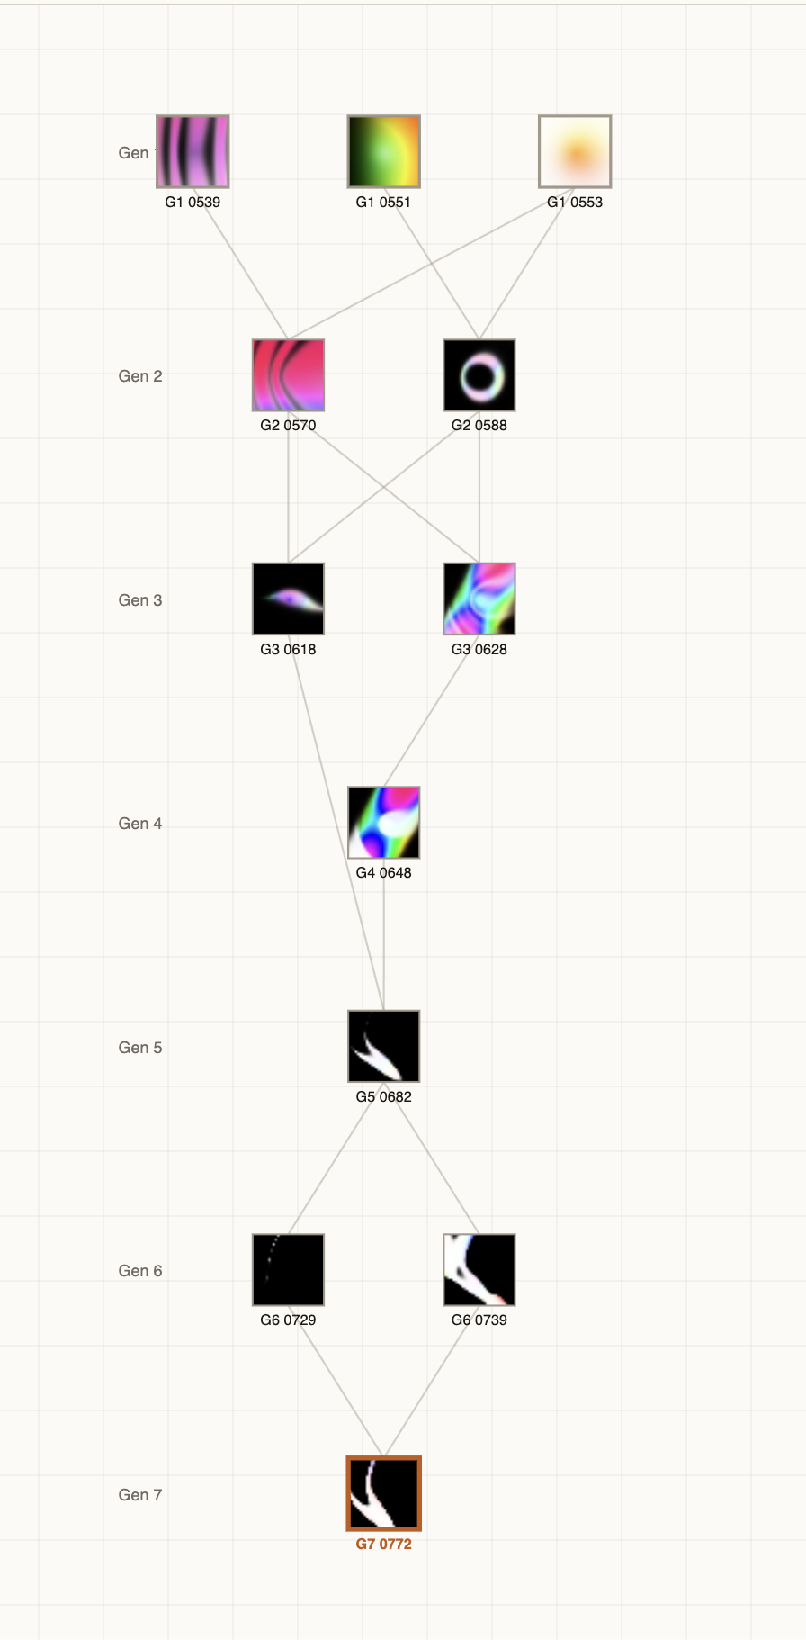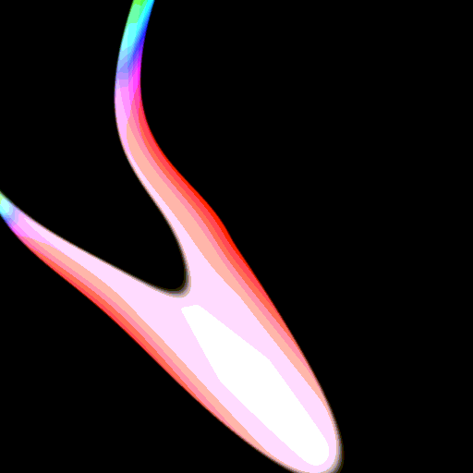
Figure 4. Phenotype x2466u8sh evolving the beginnings of apparent animacy in only 7 generations. Phylogenetic tree on the left and frame 18 of the phenotype on the right.

It’s important to note that these can be better understood as an epiphenomenon of human cognitive dispositions, which reflects our evolutionary proclivities for noticing lifelike or animate objects[][][][].

Analyses

Limitations and Future Work

Conclusion



Fig 5. Nine limbomorphs of increasing morphological complexity. They begin as a large undifferentiated mass (4a-b) before becoming thinner (4c), developing a forked tail (4d-e), a secondary bifurcation (4f-g), and eventually fine, filamentous (flagella-like) appendages (4h-i).


Fig 5. Nine limbomorphs of increasing morphological complexity. They begin as a large undifferentiated mass (4a) before becoming thinner (4b-c), developing a forked tail (4d-e), a secondary bifurcation (4f-g), and eventually fine, filamentous (flagella-like) appendages (4h-i).

Connections to Perception

Conclusion
GIFBreeder is a new form of computational media initially created as a tool for evolutionary art but it was found that lifelike beings could emerge purely under human aesthetic selection. Adding a time dimension to Picbreeder creates a new search space of compact spacetime fields which can bring images to life. By allowing humans to guide the evolutionary process of these expressions, they implicitly imbue the phenotypes with what they find most salient and interesting. Sometimes the result of this process is emergent lifelike beings, limbomorphs, which can tell us both about the nature of living things and about the cognitive dispositions of what humans find interesting or salient. This can be used to reverse engineer the appearance of life and to reverse the inverse graphics problem. Furthermore, GIFBreeder can be used as a new tool for evolutionary art and artificial life media.

Taken together, these results support a simple interpretation: animate clips occupy a regime in which most of the field is close to a stable background while a small number of localized deviations persist over time. This is exactly the sort of figure-ground organization one would expect to support apparent entity perception.

Acknowledgements
I thank the creators of Picbreeder and related interactive evolutionary systems for
establishing the conceptual and technical foundations upon which GIFBreeder stands.

Notes
My interpretation of the paper was that someone discovered that you can take picbreeder, add time, and find lifelike motion and creatures. Not that gifbreeder is some alife generator but rather that lifelike things can emerge purely under human selection.

References
- Gray, J. 1946. The mechanism of locomotion in snakes. Journal of Experimental Biology 23, 2 (December 1946), 101–120. https://doi.org/10.1242/jeb.23.2.101
- Turing, A. M. 1952. The chemical basis of morphogenesis. Philosophical Transactions of the Royal Society of London. Series B, Biological Sciences 237, 641 (1952), 37–72. https://doi.org/10.1098/rstb.1952.0012
- Murray, J. D. 1981. A pre-pattern formation mechanism for animal coat markings. Journal of Theoretical Biology 88, 1 (1981), 161–199. https://doi.org/10.1016/0022-5193(81)90334-9
- Kondo, S. and Miura, T. 2010. Reaction-diffusion model as a framework for understanding biological pattern formation. Science 329, 5999 (2010), 1616–1620. https://doi.org/10.1126/science.1179047
- Melen, G. J., Levy, S., Barkai, N., and Shilo, B.-Z. 2005. Threshold responses to morphogen gradients by zero-order ultrasensitivity. Molecular Systems Biology 1, 1 (2005), 2005.0028. https://doi.org/10.1038/msb4100036
- Skopelitis, D. S., Benkovics, A. H., Husbands, A. Y., and Timmermans, M. C. P. 2017. Boundary formation through a direct threshold-based readout of mobile small RNA gradients. Developmental Cell 43, 3 (2017), 265–273.e6. https://doi.org/10.1016/j.devcel.2017.10.003
- French, V. and Brakefield, P. M. 1992. The development of eyespot patterns on butterfly wings. Development 116, 1 (1992), 103–109.
- Monteiro, A., French, V., Smit, G., Brakefield, P. M., and Metz, J. A. J. 2001. Butterfly eyespot patterns: Evidence for specification by a morphogen diffusion gradient. Acta Biotheoretica 49, 2 (2001), 77–88. https://doi.org/10.1023/A:1010226223287
- Holló, G. 2015. A new paradigm for animal symmetry. Interface Focus 5, 6 (2015), 20150032. https://doi.org/10.1098/rsfs.2015.0032
- Timoney, K. P., Roi, G. H., and Dale, M. R. T. 1993. Subarctic forest-tundra vegetation gradients: The sigmoid wave hypothesis. Journal of Vegetation Science 4, 3 (1993), 387–394. https://doi.org/10.2307/3235597

